Power Query

Connecting to Data and Accessing Power Query Editor

Select the Data tab

Select the Queries & Connections

The Queries & Connections window will appear on the right side of the Power Query Editor

The data connections will be displayed in this window

Select the Get Data within the Data tab to add data

The list of data that can be imported will displayed

To add database (SQL) data select From ODBC

Select the ODBC for the database

To use SQL - select the Advanced options

The SQL statement window will display

Add SQL and select OK

The ODBC window will display

Select Transform Data button to enter Power Query editor

The Power Query editor window will display

Once data transformation is complete, select the Close & load

Connecting to a table/view

Select a data connection

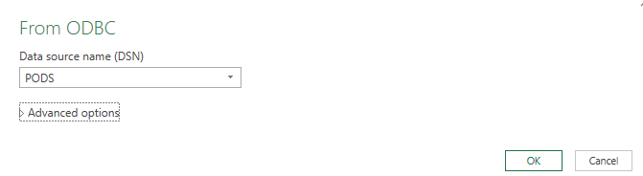

The Navigator window will appear

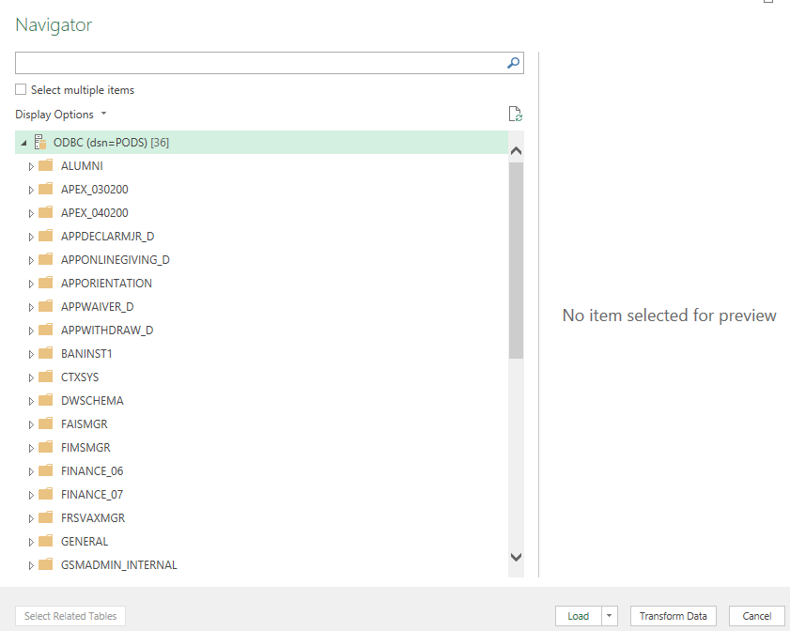

The search bar will assist in finding the data connection

Adding search criteria will limit the values viewed

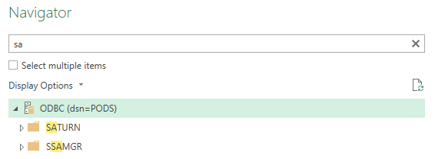

Select the table/view

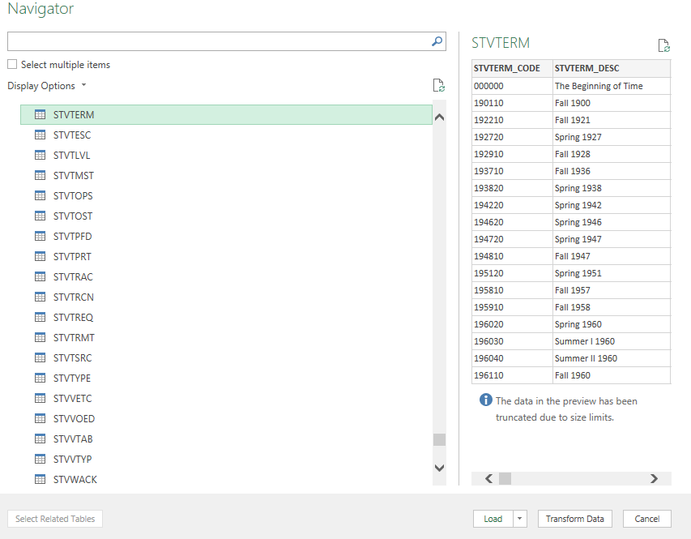

Merge Datasets

Open the data tab

Select Combine Queries – Merge and Append

In this example: Merge will be demonstrated

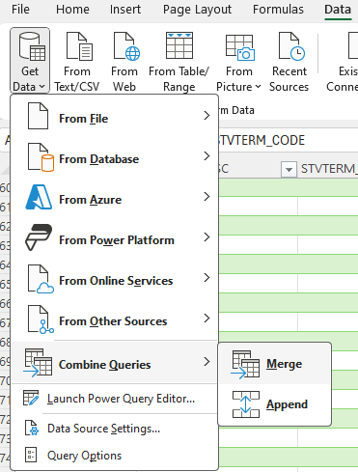

The Merge window will be displayed

Select the datasets to be merged

Then select the related field(s) for the two tables. Hold the control key for multiple fields.

The type of join can be changed

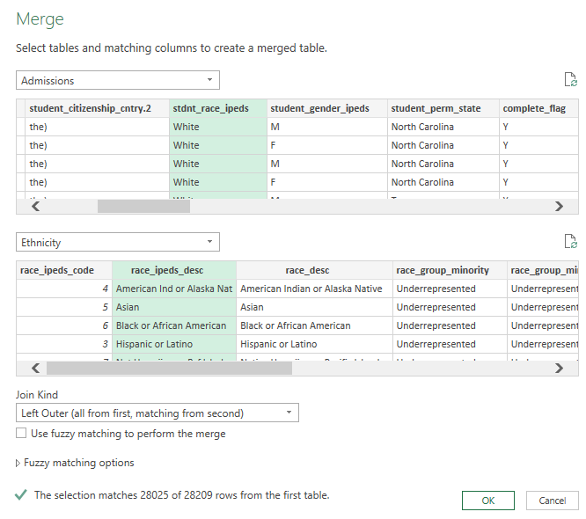

In this case the Power Query Editor will display the data from the left dataset

The right dataset will display as Table in the data field. Select the  icon.

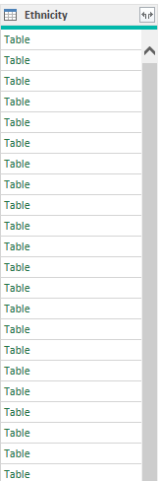

The Expand window will display.

Select (unselect) the fields desired.

Add or delete the Default column name prefix that will display the merged data.

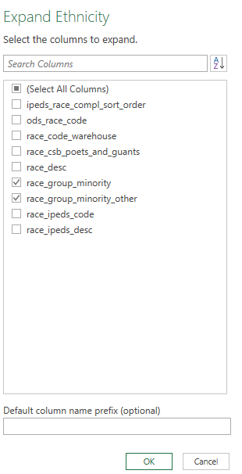

Transforming Data

Once your data is loaded into Power Query Editor, you can apply various transformations:

**Filter**: Remove rows based on conditions.

**Sort**: Arrange data in ascending or descending order.

Select arrow to access sort and filter

Change data type

Click the data type and the data type selection will display

Select the data type you want the new data



Remove columns

Right click in the field area and the below will display



**Split data**

Split column data into separate columns.

In this example, I am using the student_citizenship_cntry data field

Open the Home tab and navigate to the Split Column icon

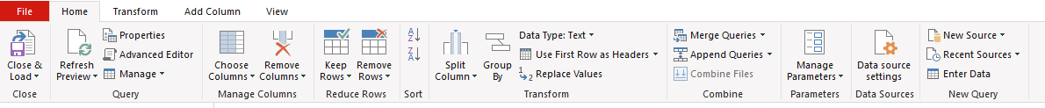

Select the down arrow and in this case select By Delimiter

The Split Column by Delimiter window will display

In this case the delimiter is identified. Select the OK button

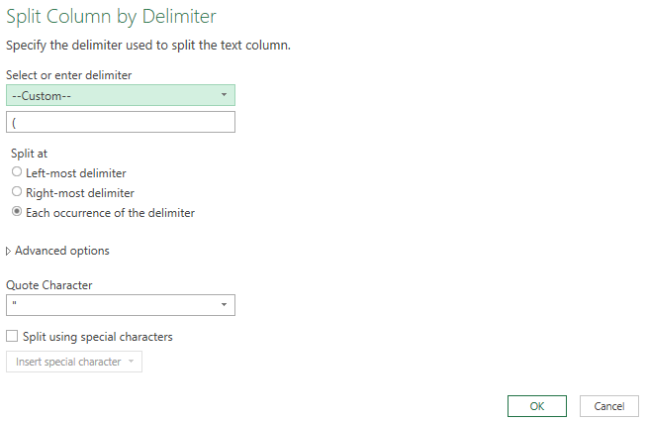

The student_citizenship_cntry field will be replaced with two fields

Upper / Lower Values​

In Power Query Editor: right click the field name then select Transform

Update Column Values

Select the field to replace values

In the Transform tab select Replace Values

The Replace Values window will display

Add the search value and the value to replace

The select OK

**Applied Steps** Located on the right side of the Power Query editor screen

**Applied Steps**

Every transformation step you apply is recorded in the "Applied Steps" pane on the right. You can:

* + - * Rearrange steps by dragging them.
      * Edit or delete steps as needed.
      * Duplicate steps to apply similar transformations elsewhere.

Refreshing Data

If your source data changes, you can refresh the query to update your workbook with the latest data:

Right-click on a table loaded from Power Query and select "Refresh" to update the data.

Add columns

Create new columns derived from existing ones (e.g., calculations, text manipulations).

Open the Add Column tab and select Custom Column

The Custom Column window will open

M Code (GUI) goes here:  
= Text.Combine({[intended_degree_1_inst], " (", [intended_degree_code_1_inst], ") - " ,[intended_major_1_inst], " (", [intended_major_code_1_inst], ")"})

Advanced Editor

For advanced users, the Advanced Editor allows you to write and edit M code (the underlying language of Power Query) directly.

See additional Notes for more information.

