Connect an online Excel file to Excel
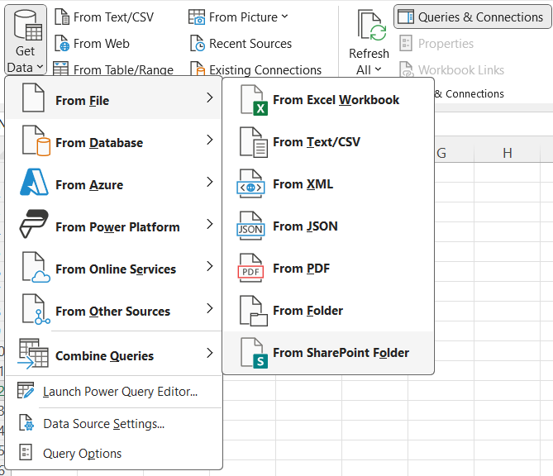

The file but you cannot use this URL:
https://uncw4.sharepoint.com/:x:/r/teams/IRDataMart/Shared%20Documents/Crosswalks/Crosswalk%20Ethnicity-Race%20Grouping.xlsx?d=w9fde461c820744f6860f9aa7956272c7&csf=1&web=1&e=9R9hfb

This is the share directory URL but do not use this URL
https://uncw4.sharepoint.com/:u:/r/teams/IRDataMart/SitePages/Home.aspx?csf=1&web=1&e=e8WrzP

Copy the URL from the search bar -
https://uncw4.sharepoint.com/teams/IRDataMart

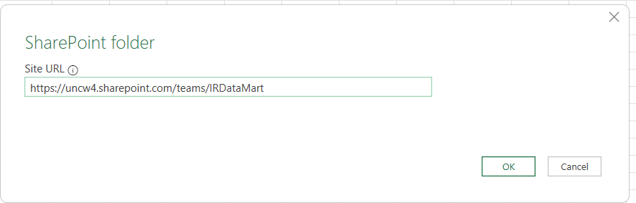

A window will appear with a list of files. Ignore the file list and select the Transform Data button
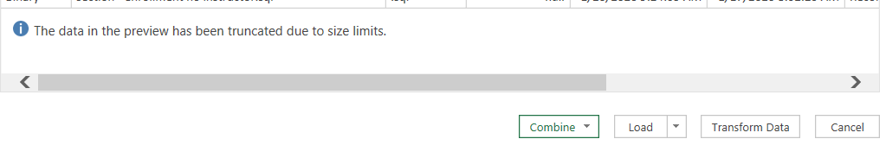
This will open the Power Query window
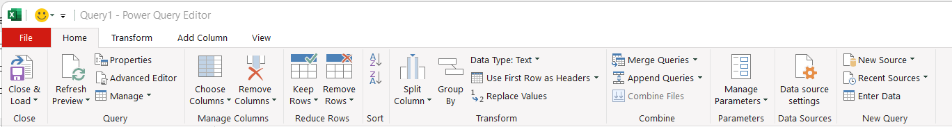

The files will be listed. Select the dropdown in the Name field

Unselect the Select All; then select the file(s) that you want to include.
Enter the text into the search bar to limit the files:
In this example, I am searching for the Crosswalk Ethnicity-Race Grouping.xlsx file so I entered “cros” into the search bar and
selected the box for that file.
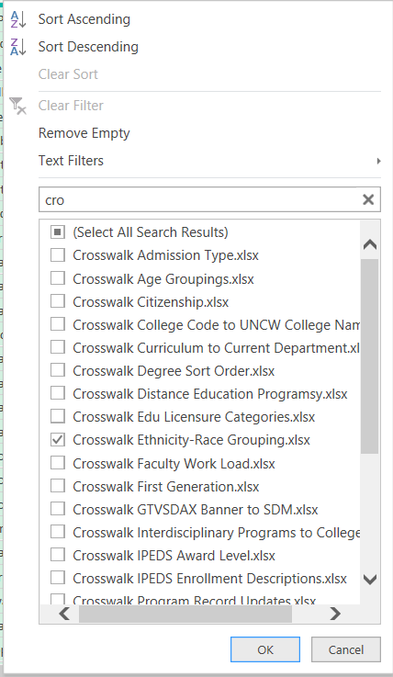

The screen will display the file selected. Click Binary under the Content

Then the screen displays the information of the Excel file. Click the Table under the Data field where the Kind field lists Table:

The steps of all the actions will display under the Query Setting box.
Rename the query in the Name textbox.
